Portable GPS Tracker
User Manual

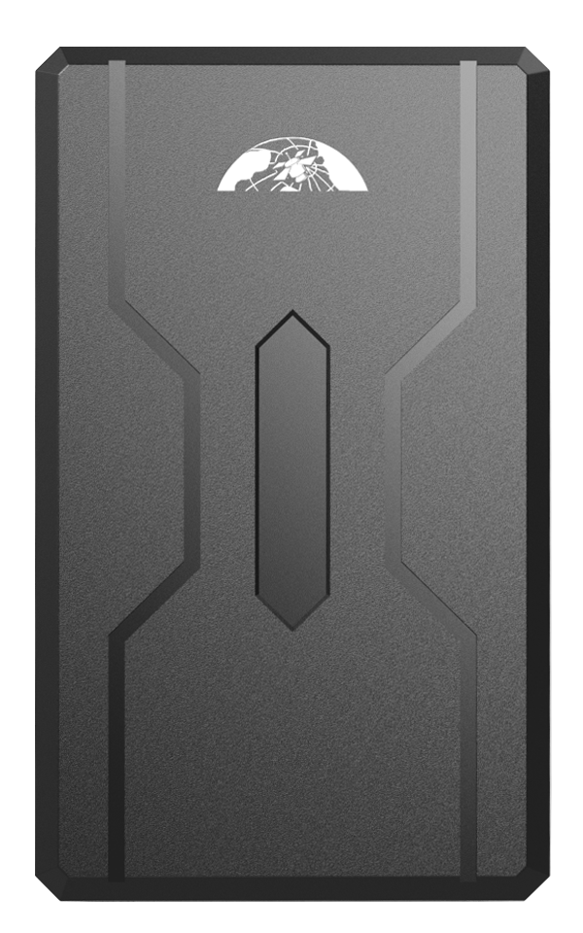

Thank you very much for purchasing our GPS tracker. The user manual will explain in detail how to operate this product. Therefore please be sure to read it carefully before using the product. Subject to change without prior notice, each change will be published in the latest product sale. The manufacturer assumes no legal responsibility for errors and omissions in this manual

Specifications
Product name | GPS TRACKER
Model | 408
DIM. | 106mm * 63mm * 37.5mm
Weight | 343g
Network | GSM/GPRS/WCDMA/LTE
Band | 4G（B1/B2/B3/B4/B5/B7/B8/B28A/B28B/B40）  3G（B1/B2/B5/B8）  2G（850/900/1800/1900Mhz）
GPS sensitivity | -165dBm
GPS accuracy | 5m
Time To First Fix | Cold status 45s  Warm status 35s  Hot status 1s
Battery | Chargeable 3.7V 10000mAh Li-ion battery
Storage Temp | -40°C to +85°C
Operation Temp | -20°C to +45°C
Humidity | 5%--95% non-condensing

Hardware description
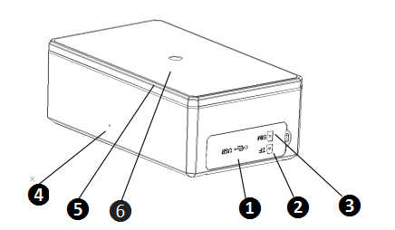
❺
❻
❹
❺
❻
❹
❶ USB port ❷ TF card slot ❸ SIM card slot
❹ Microphone ❺ Rear cover of magnet ❻Infrared induction
The USB port can be connected to a computer for charging. It can also be used for program upgrades.

Quick charger
This device supports maximum 2A current quick charger.
Charging way :
Connect the device to the AC adapter (Output voltage: 5V, current: >2A) with the original MICRO USB cable.

Installation（Model B）
If you need to connect the external power, stop the engine and SOS function, please find the 4 PIN connector wire (optional accessories) to connect it as following diagram:
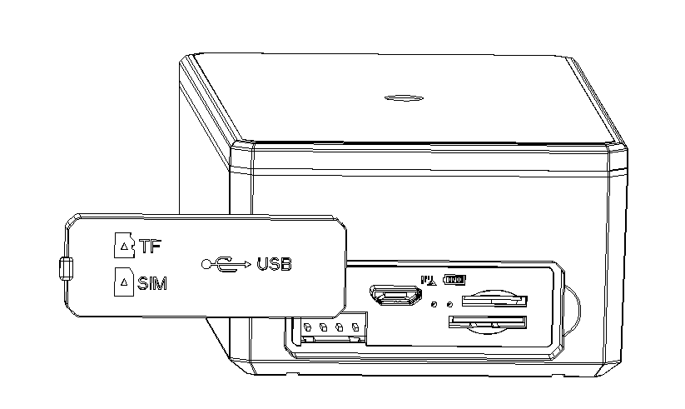

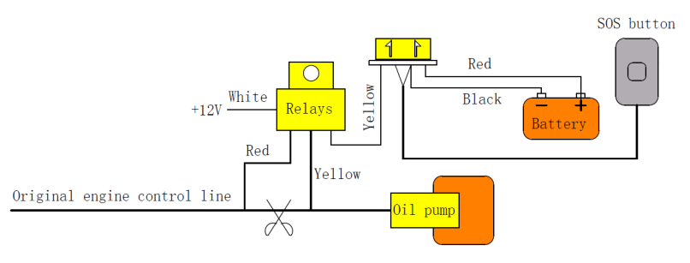
Note: Please install SOS button on the hidden place driver can touch.

Insert SIM card, turn on the device
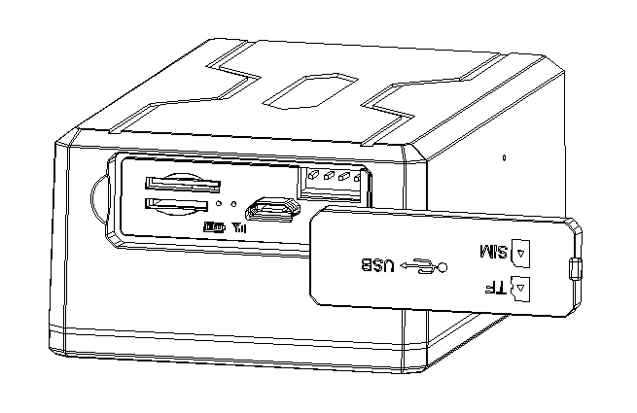
❶ Open the soft glue plug.

❷ Insert SD card as the picture shows.
❸ Insert SIM Card as the picture shows, and tracker will be turned on.
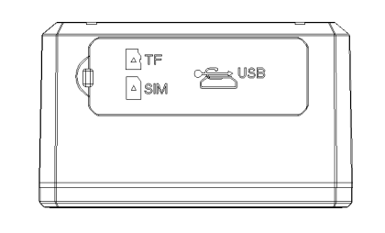
❹ Cover the soft glue plug

The device automatically turns on after inserting the card. Please bring the device outdoors for the first time to wait for about 10-40 seconds to search for GSM and GPS signals to start work normally.

Device Status Light
Indicators | Status
Power LED (Red) | Flash | Low battery
Power LED (Red) | ON | Charging
Power LED (Red) | OFF | Fully charged
GSM Light（Green） | ON | No GSM signal
GSM Light（Green） | Flash 1 time each second | GSM mode
GSM Light（Green） | Flash 2 times each second | GSM mode, GPS fixed

THIS GPS TRACKER SUPPORTS MOBILE APP, WEB SERVER PLATFORM AND SMS FOR MANAGEMENT IN MULTIPLE WAY
If you use the APP and web platform, you need a sim card to open a data plan or use a data card.
If you use SMS, you need a SIM card to enable SMS, voice calls, and caller ID.

Mobile APP
Scan the QR code to download APP
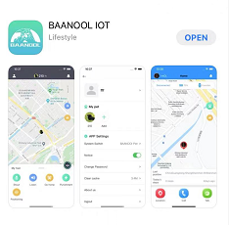
Google Play、App Store search “BAANOOL IOT” to download it
Register
Open BAANOOL IOT, register a new account and login, Choose “BAANOOL car “to enter it.
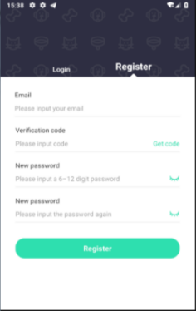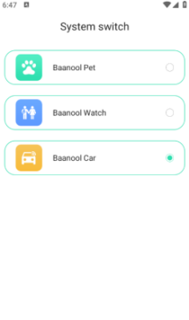
Bind Device
Click the ‘Add Device’ button on the home page and scan the IMEI number to bind a new device. Note that the IMEI number is attached to the side of the device, and the IMEI of the device can also be manually entered for binding.
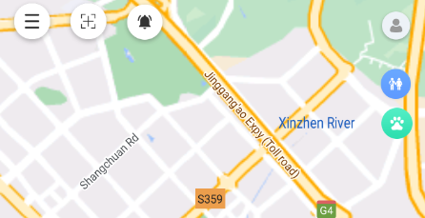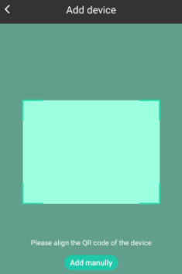
Scan QR CODE or enter the IMEI number
Click to add the device

点击添加设备

Using tracker
Under normal circumstances, the device can automatically select the APN, username and password without setting it. If the device is still offline after 3 minutes of binding, you need to set the APN and username and password according to 11.21 and 11.22. After the device comes online , you can view and manage the device.

BAANOOL IOT’s Web Version
Open www.baanooliot.com , The login account name and password are the same as phone app’s

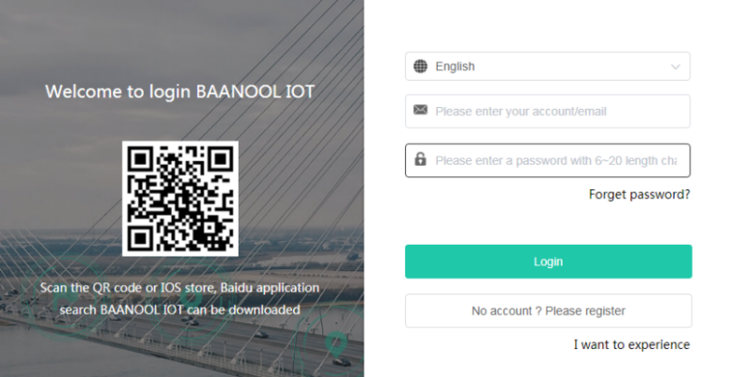

Mobile APP and BAANOOL IOT’s Web

Positioning strategy
You can click the positioning button to select the working mode and positioning strategy. When stationary, you can set a longer period of time to report location information (such as 2 hours), and when it moving, you can set a short period of time to report location information frequently (such as 3 minute). When the tracker moves, the movement trajectory will be displayed.

Working mode
Working Mode | Description | Standby Time
Real time online | The tracker is online in real time and reports its location according to the set motion/stationary intervals.  The device defaults to this mode, but not default tracking strategy | Online without positioning standby for about 50 days; 3 minutes interval when motion, 2 hours interval when stationary positioning standby for about 33 days
Smart mode | Offline when stationary (the tracker turns off GSM. SOS, tamper alarms and vibration alarms can trigger online. After SOS and tamper alarms are triggered, the device will be online in real time until the alarm is canceled). Wake up and go online when in motion. Whether it is stationary or moving, the device will report at the set interval. | 3 minutes when stationary 2 hours interval when stationary positioning standby for about 45 days
Power saving mode | After setting the wake-up time and reporting interval, the device goes offline (the device turns off GSM, SOS, tamper alarm, and shock alarm can trigger the online operation. After the SOS and tamper alarms are triggered, the device will be online in real time until the alarm is canceled). After the wake-up time is reached, the device wakes up to report the location and work 3 minutes, and then wake up regularly according to the set period to report the location. | Report once a day standby for about 180 days
* The above standby time is measured by the laboratory and is for reference only. In actual use, there may be differences due to different signal strengths and positioning frequencies.

Positioning interval
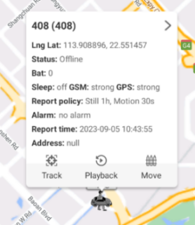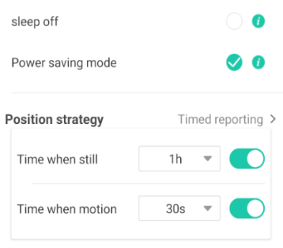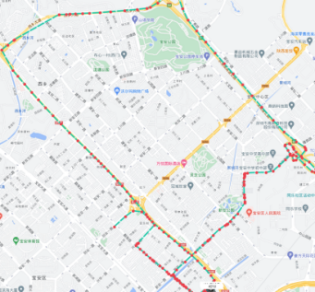

History playback
You can click the playback button to view the historical track
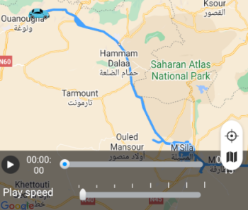

Geo-fence
After multiple geo fences are set up on the APP or platform, the geo fence alarm will be triggered when the device enters or leaves the set fence.
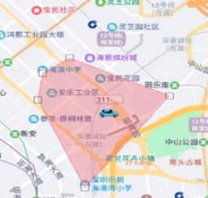

Movement alarm
Draw a circle centered on the current location of the device. When the device leaves the current position and exceeds the range, the movement alarm will be triggered.
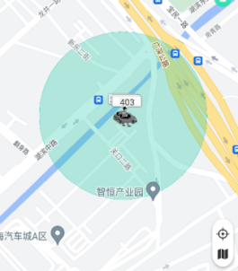

Over speed alarm
After setting the overspeed value, overspeed alarm will be triggered when the device speed exceeds the set threshold.

Shock alarm
Turn on shock alarm function when the device is stationary, the shock alarm will be triggered when the device moves or vibrates.

Low battery alarm
When the tracker's built-in battery voltage is close to 3.55V, tracker will send a low battery alarm every 15 minutes, a total of 2 times.

External power disconnection alarm (Model B)
This function is turned off by default. When it is activated and the external power supply is disconnected, the device will send an external power disconnection alarm.

SOS Alarm (Model B)
Press the SOS button for 3 seconds and the device will send SOS alarm.

Tamper alarm
The tracker has a built-in light sensor. When the tracker is removed after installation, tamper alarm will be triggered. This function is turn off by default.

Remote immobilizing (Model B)
Cut oil and power off delayed mode, Cut off oil and power immediately mode, Resume oil and power

Listen
Listen for 15 seconds per request

Other function settings
You can control the device to stop alarming, check sim card balance, update firmware, reset the device, restore factory settings, set shock sensitivity, authorization number, times of alarms, time zone, external power on/off, tamper alarm on/off, vibration alarm on/off, Vibration sensitivity, smart angle updating settings, tracker password, check device details, operation records, and installation information.

* If you prefer to use the mobile APP and web version to manage your device, you do not need to pay attention to the following content.

SMS Functions
The device turns on GPRS by default. If you use only SMS to manage the device, it is recommended to turn off GPRS by referring to the 11.25 command.
Attention：
When reading this user manual, you will notice that we have used "+" and "space"between some words;"+" between two words means they should be written together as one word and "space" between two words means you should leave one character space between two words.

Changing password
SMS command: password+old password+space+new password, Response: password ok
The default password is 123456, which must be changed when using it for the first time.

Authorization
Set up: admin+password+space+Mobile phone number, Response: admin ok
Cancel：noadmin+password+space+authorization number，Response: noadmin ok
Call the tracker 10 times in succession, the number will be authorize automatically as the first number and tracker response “add master ok”
Up to 5 numbers can be set and authorized, and only authorized number can receive alarm message.

Single Tracking
SMS Command：position+password, tracker reply with the location information and click the link to view the device location on the map.
Make a call to the tracker, and the tracker will automatically hang up and reply with a positioning message.
If there aren’t any authorized numbers set-up, it will reply all calls with a location report; if there are authorized numbers set-up, then it will not respond when an unauthorized number calls it.

Positioning strategy

Working mode
Real time online：online+password, GSM always online, the location can be queried at any time, and whether the device is stationary or moving, the location will be reported at set intervals.
Smart mode: sleep+password, sleep when the tracker is stationary (The tracker cannot be contacted by call or SMS. SOS, tamper alarm, and shock alarms can be triggered. After the SOS and dismantling alarms are triggered, the device will not be able to sleep until the alarm is cleared), the tracker will be awakened when it moves, and whether it is stationary or moving, the device will report its position according to the set multiple positioning intervals.
Power saving mode: psm+password+space+wake-up time (hour: minute)+space+reporting interval (hour)，After setting the wake-up time and reporting interval, the device sleeps(The tracker cannot be contacted by call or SMS. SOS, tamper alarm, and shock alarms can be triggered. After the SOS and tamper alarms are triggered, the device will not be able to sleep until the alarm is cleared). When the wake-up time is reached, the device wakes up and reports position and work for 3 minutes, and then wake up regularly according to the set period to report the position. For example, psm+password+space+9:30+space+2 means that the device wakes up at 9:30 to report and then wakes up and reports every 2 hours.

Positioning interval
SMS Command：fix+020s+002h+005n+password，tracker will report at 20 seconds interval when the device is moving, and 2 hour when it is stop , and only report 5 times, 005n means limited to 5 times of positioning, ***n means unlimited times.
Cancel：nofix+password，response：nofix ok

Movement alarm
SMS command：move+password+space+radius, response: move ok
Cancel: nomove+password, response: nomove ok
Draw a circle with the current location of the tracker as the center. Once the tracker exceeds the radius, a movement alarm will be triggered.

Over speed alarm
SMS command：speed+password+space+speed value, reply: speed ok
Cancel: nospeed+password, response: nospeed ok
When the speed exceeds the set speed value, overspeed alarm will be triggered.

Shock alarm
Turn on shock alarm function when the device is stationary, the shock alarm will be triggered when the device moves or vibrates.
Turn on: shock+password, response: shock ok
Turn off: noshock+password, response: noshock ok
Vibration sensitivity defaults to level 2, which can be set to 1, 2, or 3.
SMS command: sensitivity+password+space+2

Low battery alarm
This feature is activated by default, when the tracker's built-in battery voltage is close to 3.55V, tracker will send a low battery alarm every 15 minutes, a total of 2 times.
Turn off: lowbattery+password+space+off, response: lowbattery off ok
Turn on: lowbattery+password+space+on, response: lowbattery on ok

Extpower disconnection alarm (Model B)
It is turned off by default. When turned on and the external power supply is disconnected, the device will trigger an external power disconnection alarm.
Turn on：extpower+password+space+on，Response：extpower on ok
Turn off：extpower+password +space+off，Response：extpower off ok

SOS alarm (Model B)
Press the SOS button for 3 seconds and the device will trigger an emergency alarm.

Tamper alarm
The terminal has a built-in light sensor. When the terminal is removed after installation, a tamper alarm will be triggered. It is turned off by default.
Turn on:tamper+password,Response:tamper ok
Turn off:notamper+password,Response:notamper ok

Stop alarm
Command: stopalarm+password, Response:stopalarm ok, The device will stop all alarms.

Remote Immobilizing (Model B)
Delayed immobilizing
Command: stop+password. When the current speed of the vehicle is greater than 20km/h, the command will not be executed immediately. it will be executed only after the vehicle speed is less than 20Km/h.
Immobilizing immediately
Command: quickstop+password, no matter whether the vehicle speed is greater than 20km/h, the command will be executed immediately.
Resume fuel and power supplying
Command: resume+password, restore fuel and power supply.

Listen
The default is "track" (positioning mode). When dialing the device, positioning information will be response
Command: listen+password, switch to listening mode, dial the device, and it will enter the call state.
Command: tracker+password, return to positioning mode.

Configure times of alarm
The number of times of SOS and external power disconnection alarms can be set.
Command: xtime+password+times value，Response： xtime ok
Send once by default.

SIM Card Balance Enquiry
Way1
Command: balance+password+space+operator number+space+code
The device will forward the received text message from the operator to the sender of the command

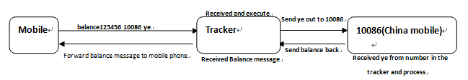
Way2
Command: forward+password+space+operator number
When the network operator sends a text message to remind you to top up your sim card, the tracker will forward the notification message to the authorized number

Check status
Command: check+password, reply: battery level, GPS signal, GSM signal, GPRS status, APN, UP, IP, port, etc.

Check IMEI
Command: imei+password, reply: device IMEI

Time Zone Setting
The device automatically synchronizes the local time zone. If the time is wrong, you need to set the time zone.
Command: time+space+zone password+space+time zone, reply: time ok

Hardware Reset
Command: reset+password, response: reset ok

APN Setting
Command: apn+password+space+local apn, response: apn ok
Settings are only required when using the APP and web version

Configure User Name and Password of GPRS Network
Command: up+password+space+user+space+Password, response: up ok
Settings are only required when using the APP and web version

Set Server IP/Domain Name and Port
Command: adminip+password+space+IP/DNS+space+port, reply: adminip ok
No setup required to use our BAANOOL IOT server, the default is BAANOOL domain name and port

TCP/UDP Switch
Command: tcp+password, response: tcp ok
Command: udp+password, response: udp ok
No setup required to use our BAANOOL IOT server

SMS Mode
Command: SMS+password
Device Reply: sms ok
The device default mode is GPRS mode, if user prefer to sms managing gps device, please use this command to close gprs mode

GPRS Mode
Command: gprs+password
Device response: gprs ok

Initialization
Command: begin+password
Device response: begin ok
All commands setting will return to default factory settings

Cautions
Please be sure to follow when using:
1. Keep the tracker used in a dry environment. The humid environment can easily damage
internal circuits.
2. Please do not put it in a dusty environment.
3. Do not put the tracker in overheated or overcooled places.
4. Handle carefully. Don’t vibrate or shake it violently.
5. Please clean with a dry cloth, do not use chemicals and detergents.
6. Please do not dissemble the device; this may lead to internal circuit failure.
7. Please read the user manual carefully before installation and operation, and understand
voltage range. Otherwise, it won’t work properly or damage the tracker.

Troubleshooting
Faults | Solution
Fail to turn on | - Please check if the power wiring is correct?  - Please check if the power voltage is correct?
No GSM signal | - Check whether the SIM card is put in place.  - Whether the SIM card is a GSM network SIM card.  - Don’t turn on the PIN code.  - Call forwarding cannot be opened.
No GPS signal | The device needs to be in an unobstructed position to ensure that it can receive GPS signals normally.
No response for SMS command | - No credit on SIM card.  - The password is incorrect or the format of the SMS command is incorrect.
No response for a call/No alarm notification message | 1. Did you have set up the authorized phone number?  2. If authorized number exists, did you make the call from an authorized phone number?  3. The format of the phone number is incorrect.

