**GPS Tracker User Manual**

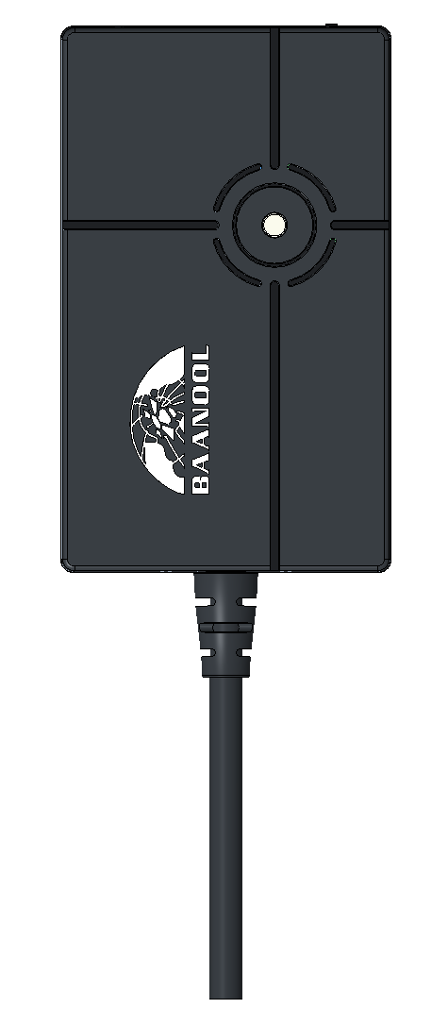

Thank you for purchasing the tracker. This manual shows how to operate the device smoothly and correctly. Make sure to read this manual carefully before using this product. Please note that specification and information are subject to changes without prior notice in this manual. Any change will be integrated in the latest release. The manufacturer assumes no responsibility for any errors or omissions in this document.

1. Specifications

|  |  |
| --- | --- |
| Product name | GPS TRACKER |
| Model | 401AB |
| DIM. | 6.78x4.1x2.15 cm |
| Weight | 58g |
| Network | LTE |
| Band (4G) | Latin America（B2/B3/B4/B5/B7/B8/B28A/B28B）  North America（B2/B4/B5/B7/B12/B13/B66/B28A）  Europe, Asia and Africa（B1/B3/B5/B7/B8/B20/B28A/B40） |
| GPS sensitivity | -165dBm |
| GPS accuracy | 5m |
| Time To First Fix | Cold status 45s  Warm status 35s  Hot status 1s |
| Voltage of power | 12V-24V |
| Battery | Chargeable 3.7V 90mAh Li-ion battery |
| Storage Temp. | -40°C to +85°C |
| Operation Temp. | -20°C to +45°C |
| Humidity | 5%--95% non-condensing |

1. Terminal Installation
2. Please ask a qualified engineer to install it.
3. The installation environment should ensure that the GSM and GPS signals are good
4. Please do not install it in a dusty and humid environment.
5. Find the 5PIN wiring harness provided with the product, insert it into the corresponding wiring hole of the product, and connect to the original car circuit as shown in the following Wiring Diagram:

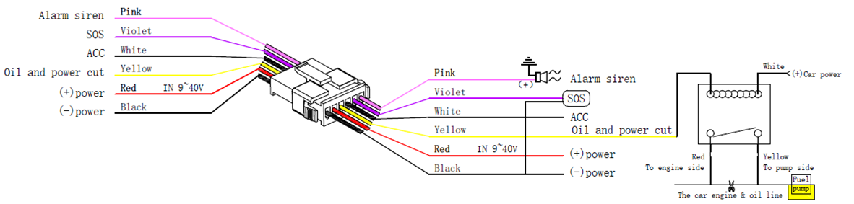

1. SIM card installation

Please be sure to confirm that the SIM card network frequency band is the network frequency band supported by the device. Caller ID must be turned on and the PIN code must be turned off. The call forwarding function cannot be turned on.

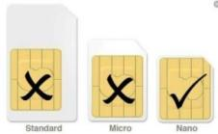

1. After inserting the SIM card, the GPS device will power on automatically
2. Device Status Light

**Green light**: Flashes every 1 second when GSM network signal normally, flashes every 3 seconds when works in GPRS mode; always on when no GSM network.

**Blue light**: Flashes every 1 second when GPS signal is normal; flashes 3 times per second when GPS signal is very good and turns off if lost fix to satellites.

1. This GPS Tracker Support Mobile APP, Web Server Platform,Bluetooth and SMS for Management in Multiple Ways

If you use the mobile APP or web server platform, you need a SIM card to activate gprs data package or use a data card.

If you use SMS, you need to activate the SMS, voice call, and caller ID functions on the SIM card.

1. Mobile APP

**Scan the QR code to download APP**

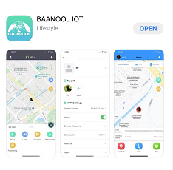

Google Play、App Store search “BAANOOL IOT” to download it

**Register**

Open BAANOOL IOT, register a new account and login, Choose “BAANOOL car” to enter it.

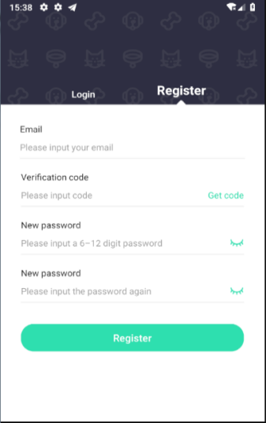 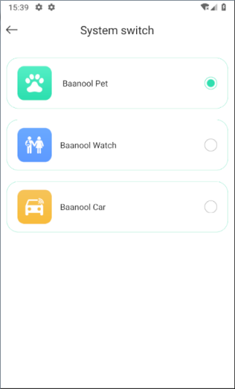

**Bind Device**

Click the ‘Add Device’ button on the home page and scan the IMEI number to bind a new device. Note that the IMEI number is attached to the side of the device, and the IMEI of the device can also be manually entered for binding.

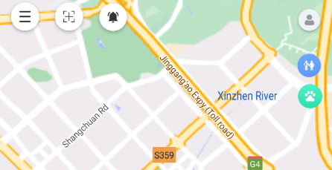 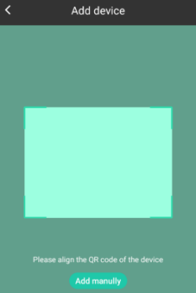

Scan QR CODE or enter the IMEI number

Click to add the device

点击添加设备

**Use Device**

Usually, the device can automatically recognize and select the APN, user name and password of GPRS settings.

If the device is still offline after 3 minutes of binding, you need to set the APN and username and password in Bluetooth or SMS according to 10.16 and 10.17. After the device comes online normally, you can view and manage the device.

1. Web Platform Version

BAANOOL IOT’s Web Version Webiste : [www.baanooliot.com](http://www.baanooliot.com) , The login account name and password are the same as phone app’s

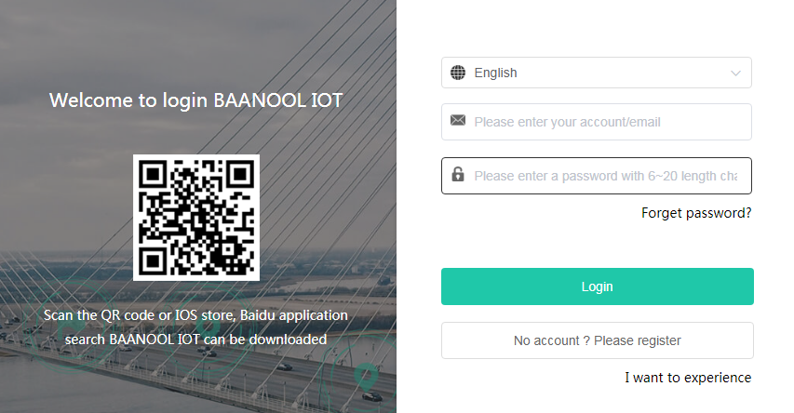

1. Function details of mobile APP and web platform

## Location reporting strategy

You can click the “Continuous tracking” button to select the working mode and location report strategy. When stationary, you can set a longer period of time to report location information (such as 1 hours), and when it moving, you can set a short period of time to report location information frequently (such as 10 second). When the tracker moves, the movement trajectory will be displayed.

### Working mode

|  |  |
| --- | --- |
| Working Mode | Description |
| Real time online | The tracker is online in real time and reports its location according to the set motion/stationary intervals. |
| Smart mode | Offline when stationary (SMS,alarms can trigger online. After SOS alarms are triggered, the device will be online in real time until the alarm is canceled). Wake up and go online when in motion. Whether it is stationary or moving, the device will report at the set interval.  The tracker is smart mode by default and reports its location at intervals of 10 seconds of movement and 1 hour of stationary. |

### Positioning interval

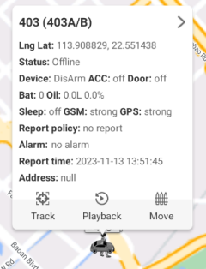 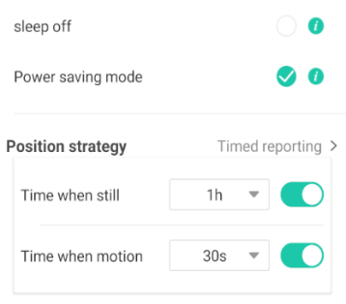 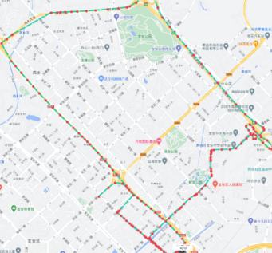

## History playback

You can click the playback button to view the historical track

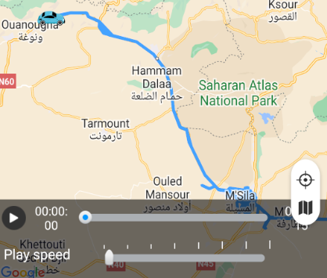

## Remote immobilizing

Cut oil and power off delayed mode, Cut off oil and power immediately mode, Resume oil and power

## Arming/Disarming

Arming 、Silent Arming、Disarming

## Alarm function in arming state

### ACC Alarm

If the ignition of the vehicle has been switched “ON” (Key is rotated to “ACC ON” position when tracker works in arming mode, the siren will beep for 20 seconds, and if the ignition is still on, then the siren will beep for another 20 seconds with 20 seconds pause, disarming to quit the alarm.

### Shock alarm

When tracker works in arming state, the shock alarm will be triggered when the device moves or vibrates. Shock alarm will only sound once within 3 minutes. The siren alarm will sound for 5 seconds for the first time within three minutes, the siren alarm will sound for 5 seconds for the second time, and the siren alarm will sound for 10 seconds when triggered again

## Other alarm functions

### Low battery alarm

When the tracker's built-in battery voltage is close to 3.55V, tracker will send a low battery alarm every 15 minutes, a total of 2 times.

### External power disconnection alarm

This function is turned on by default. When the external power supply is disconnected, the device will send an external power disconnection alarm.

### SOS Alarm

Press the SOS button for 2 seconds (or press the remoter button for 3 seconds)the device will trigger an emergency alarm.

### Geo-fence

After multiple geo fences are set up on the APP or platform, the geo fence alarm will be triggered when the device enters or leaves the set fence.

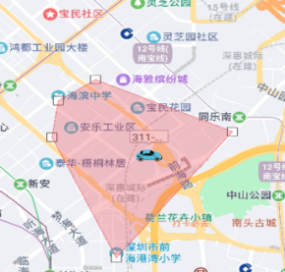

### Movement alarm

Draw a circle centered on the current location of the device. When the device leaves the current position and exceeds the range, the movement alarm will be triggered.

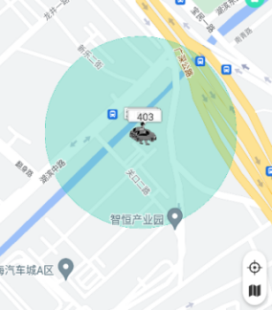

### Over speed alarm

After setting the over speed value, over speed alarm will be triggered when the device speed exceeds the set threshold.

## Bluetooth configuration parameters

You can click the Bluetooth icon on the App login page or the home page after login to enter the Bluetooth configuration parameter function interface, and click "Bn401" to directly modify device parameters after the connection is successful.All SMS commands can be set via Bluetooth.

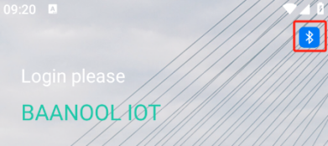 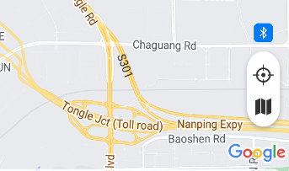 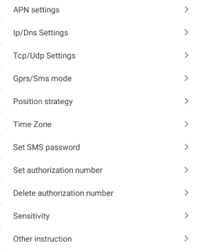

## Other function settings

You can control the device to stop alarming, check sim card balance, update firmware, reset the device, restore factory settings, set shock sensitivity, authorization number, times of alarms, time zone, external power on/off, , shock alarm on/off, smart angle updating settings, tracker password, check device details, operation records, and installation information.

1. Bluetooth automatic arm/disarm

Open the phone Settings, find the Bluetooth menu, open Bluetooth, search for Bluetooth named "Bn401", click Connect, enter the machine password, and then the pairing succeeds.

When you are far away from the terminal and the Bluetooth connection is disconnected, the terminal automatically arm.

When close to the terminal, Bluetooth automatically connected, the terminal automatically disarm.

**Note:** When using other methods (remote control, SMS command, app, web version, Bluetooth setting parameters) after arm, Bluetooth sensor automatic arm/disarm will be invalid, until through other means of disarm, Bluetooth sensor automatic arm. If you do not use Bluetooth sensing, please unpair in the Bluetooth menu of your phone.

1. Remote Controller（For B model）

|  |  |  |
| --- | --- | --- |
| Key | Function | Descriptions |
|  | Arming | Press for 0.5 second, siren beep one time. If the vehicle is in the ignition state, it cannot enter the arming state, and the siren will not beep. |
|  | Disarming | Press for 0.5 second, siren beep 2 times ,all alarms will stop |
|  | Silent arming | Press for 0.5 second when it is in disarm state, siren beep one time. In silent mode, the siren will not sound even if an alarm is triggered. Disarm will quit from silent mode. |
|  | SOS | Press for 3 seconds, Tracker will send SOS alert to authorized phone numbers. Siren won’t sound. |
|  | Deterrence/Car locate | Press for 0.5 second when it is in arm state, siren will beep 10 seconds, press  disarm to quit |

* If you prefer to use the mobile APP and web version to manage your device, you do not need to pay attention to the following content.

1. SMS functions

The device works on GPRS & SMS by default，If you use only SMS to manage the device, it is recommended to turn off GPRS by referring to the 10.20 command to save power and data.

**Attention**：

When reading this user manual, you will notice that we have used "+" and "space"between some words;"+" between two words means they should be written together as one word and "space" between two words means you should leave one character space between two words.

## Changing password

SMS command: password+old password+space+new password, Response: password ok

The default password is 123456, which must be changed when using it for the first time.

## Authorization

Set up: admin+password+space+Mobile phone number, Response: admin ok

Cancel：noadmin+password+space+authorization number，Response: noadmin ok

Up to 5 numbers can be set and authorized, and only authorized number can receive alarm message

## Single Tracking

SMS Command：position+password, tracker reply with the location information and click the link to view the device location on the map.

## Positioning strategy

### Working mode

Real time online：online+password, GSM always online, the location can be queried at any time, and whether the device is stationary or moving, the location will be reported at set time intervals.

Smart mode: sleep+password, Offline when stationary (SMS, and alarms can trigger online. After SOS and ACC alarm are triggered, the device will be online in real time until the alarm is canceled). Wake up and go online when in motion. Whether it is stationary or moving, the device will report at the set time interval.

### Positioning interval

SMS Command：fix+020s+002h+005n+password，tracker will report at 20 seconds interval when the device is moving, and 2 hour when it is stop , and only report 5 times, 005n means limited to 5 times of positioning, ***n means unlimited times.

Cancel：nofix+password，response：nofix ok

## Remote immobilizing

**Delayed immobilizing**

SMS command: stop+password

When receiving stop command, tracker will check speed and reply"it will be executed after speed less than 20KM/H". If speed is higher than 20KM/H, and delay executing this command until the speed is less than 20KM/H.

**Immobilizing immediately**

SMS command: quickstop+password，Regardless of whether the vehicle speed is greater than 20km/h，Tracker will immobilize the vehicle immediately.

**Resume fuel and power supplying**

SMS command: resume+password

This means tracker will now resume the fuel & power supply.

## Arm/Disarm

Arm：arm+password，Response：Tracker is activated，the vehicle terminal enters the armed state. If the vehicle is in the ignition state（ACC is ON），it cannot enter the armed state , and then reply “set up fail! pls turn off ACC”

Silent arming：silent+ password，Response：silent ok!，the terminal enters the silent arming state. After the alarm is triggered, the siren does not sound, but an alarm text message will be sent to the authorized number

Disarming：disarm+ password，Response：Tracker is deactivated，The device will stop all alarm

## Alarm function in arming state

### ACC Alarm

Tracker will send “ACC alarm + latitude / longitude” to authorized numbers if the ignition of the vehicle has been switched “ON” (Key is rotated to “ACC ON” position when tracker works in arming state. The siren will beep for 20 seconds, and if the ignition is still on, then the siren will beep for another 20 seconds with 20 seconds pause,disarming to quite the alarm.

### Shock Alarm

When the tracker is in the armed state, when the device moves or shock, it will send SMS message "Sensor alarm + latitude and longitude" to the authorized number. The shock alarm will only be sent once within 3 minutes. The alarm siren will beep for 5 seconds for the first time within three minutes. The alarm siren beeps for 5 seconds and then beeps for 10 seconds.

Shock sensitivity defaults to level 2, which can be set to 1, 2, or 3.

SMS command: sensitivity+password+space+2

## Other alarm functions

### Low battery alarm

This feature is activated by default, when the battery voltage is close to 3.55V, tracker will send alert message to authorized numbers for 2 times at 15 minutes interval.

Turn off：lowbattery+password+space+off，Tracker response: lowbattery off ok

Turn on：lowbattery+password+space+on，Tracker response：lowbattery on ok

### External power disconnection alarm

It is turned on by default. When turned on and the external power supply is disconnected, the device will trigger an external power disconnection alarm.

Turn on：extpower+password+space+on，Response：extpower on ok

Turn off：extpower+password +space+off，Response：extpower off oK

### SOS alarm

Press the SOS button for 2 seconds (or press the remoter button for 3 seconds)the device will trigger an emergency alarm.

### Movement alarm

SMS command：move+password+space+radius, response: move ok

Cancel: nomove+password, response: nomove ok

Draw a circle with the current location of the tracker as the center. Once the tracker exceeds the radius, a movement alarm will be triggered

### Over speed alarm

SMS command：speed+password+space+speed value, reply: speed ok

Cancel: nospeed+password, response: nospeed ok

When the speed exceeds the set speed value, overspeed alarm will be triggered

## Configure times of alarm

The number of times of SOS、external power、ACC alarms can be set

Command: xtime+password+times value，Response：xtime ok

Send once by default.

## ACC ON/OFF Alert

This function is off by default. If tracker detect “ignition on” signal , tracker will send “ACC on+latitude& longitude” to authorize number to tell you the vehicle has been started；When detect “ignition off” signal, it will send “ACC off+ latitude & longitude” to tell you the vehicle has been stopped.

Turn on：ACC+password，Tracker Response：ACC ok

Turn off: noacc+password，Tracker response：noacc ok

## SIM Card Balance Enquiry

Way **1**

Command: balance+password+space+operator number+space+code

The device will forward the received text message from the operator to the sender of the command

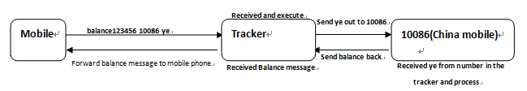

Way2

Command: forward+password+space+operator number

When the network operator sends a text message to remind you to top up your sim card, the tracker will forward the notification message to the authorized number

## Check status

Command: check+password, reply: battery level, GPS signal, GSM signal, GPRS status, APN, UP, IP, port, etc

## Check IMEI

Command: imei+password, reply: device IMEI

## Time Zone Setting

The device automatically synchronizes the local time zone. If the time is wrong, you need to set the time zone.

Command: time+space+zone password+space+time zone, reply: time ok

## Hardware Reset

Command: reset+password, response: reset ok

## APN setting

Command: apn+password+space+local apn, response: apn ok

Settings are only required when using the APP and web version

## Configure User Name and Password of GPRS Network

Command: up+password+space+user+space+Password, response: up ok

Settings are only required when using the APP and web version

## Set Server IP/DNS

Command: adminip+password+space+IP/DNS+space+port, reply: adminip ok

No setup required to use our BAANOOL IOT server, the default is BAANOOL domain name and port

## Tcp/Udp Switch

Command: tcp+password, response: tcp ok

Command: udp+password, response: udp ok

No setup required to use our BAANOOL IOT server

## SMS mode

Command: SMS+password

Device Reply: sms ok

The device default mode is GPRS mode, if user prefer to sms managing gps device, please use this command to close gprs mode

## GPRS mode

Command: gprs+password

Device response: gprs ok

## Initialization

Command: begin+password

Device response: begin ok

All commands setting will return to default factory settings

1. Accessorries

|  |  |  |  |  |
| --- | --- | --- | --- | --- |
| No. | Photo | Name | Specifications | Applicable model |
| 1 | 线材 | Harness |  | Standard |
| 2 | 继电器 | Relay |  | Standard |
| 3 |  | Remote control |  | For B model |
| 4 |  | Siren | 12V/24V | Optional |

1. Cautions

Please be sure to follow when using：

1. Keep the tracker used in a dry environment. The humid environment can easily damage

internal circuits.

2. Please do not put it in a dusty environment.

3. Do not put the tracker in overheated or overcooled places.

4. Handle carefully. Don’t vibrate or shake it violently.

5. Please clean with a dry cloth, do not use chemicals and detergents.

6. Please do not dissemble the device; this may lead to internal circuit failure.

7. Please read the user manual carefully before installation and operation, and understand

voltage range. Otherwise, it won’t work properly or damage the tracker.

1. Troubleshooting

|  |  |
| --- | --- |
| Faults | Solutions |
| Fail to turn on | Please check if the power wiring is correct |
| No GSM signal | 1. Check whether the SIM card is put in place. 2. Whether the SIM card is a GSM network SIM card. 3. Don’t turn on the PIN code. 4. Call forwarding cannot be opened |
| No GPS signal | The device needs to be in an unobstructed position to ensure that it can receive GPS signals normally |
| No response for SMS command | The password is incorrect or the format of the SMS command is incorrect |
| Fail to stop engine | Please check whether the engine stop wiring connected correctly again |
| Remote control cannot be used | Turn off tracker, and turn it on to program the remote control again |